The Intrauterine Device (IUD)

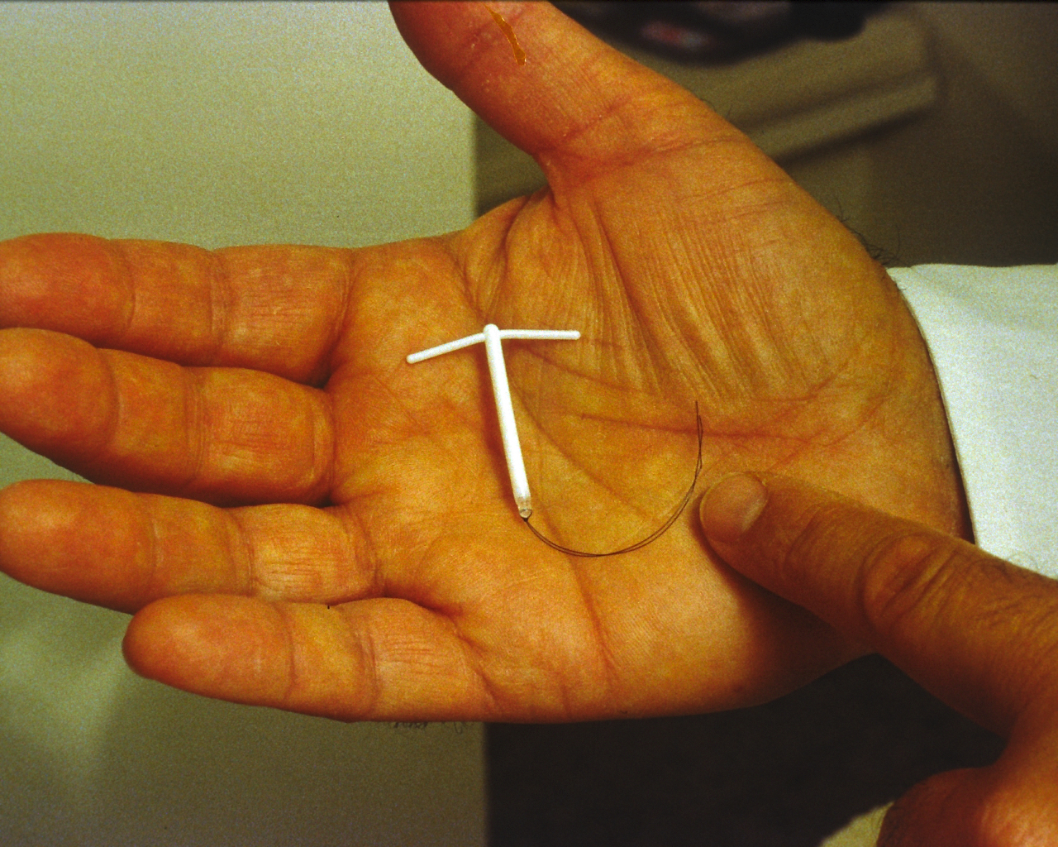 | This is often called the COIL  The IUD is a small copper and plastic device which is put into your uterus (womb)
 | It is 99% effective
 | It can stay in place for 5 to 10 years depending on type.
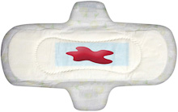   | Side Effects  Your periods may be heavier or longer. This may improve after a few months.  Your periods may be more painful
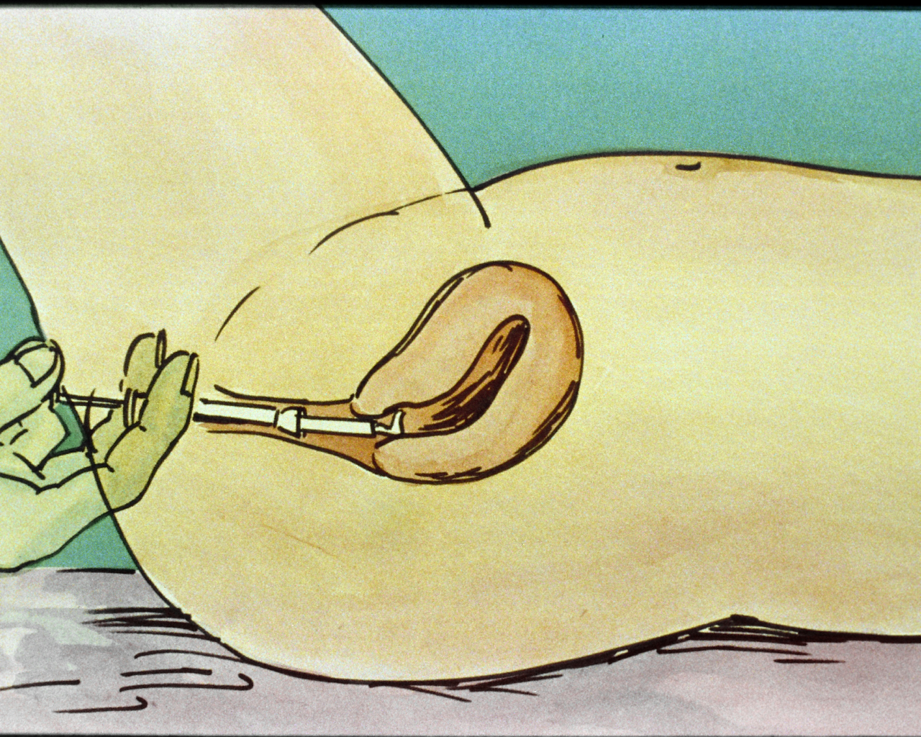  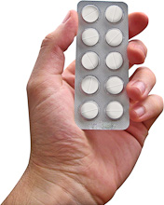 | Other Comments  It requires a small procedure to put in and take out the IUD  Not affected by other medicines
PH/LH BODYWISE 2010

